Name: Bilal abid abbasi
Id:45961
Opp lab:
Lab task 05:

Program#1:
Online shopping cart:

#include <iostream>
using namespace std;

class Product{
private:
int productID,quantity;
string name;
double price;
public:
Product(){
productID = 0;
quantity = 0;
name = "Unknown";
price = 0.0;

// cout<<"Default Constructor Called\n";
}

//Parameteraized Constructor
Product(int pid, string name, int qty, double p){
productID = pid;
quantity = qty;
this->name = name;
price = p;

// cout<<"\nParametarized Constructor Called\n";
}

//copy Constructor
Product(Product &obj){
productID = obj.productID;
quantity = obj.quantity;
name = obj.name;
price = obj.price;

cout<<"\nCopy Constructor Called\n";
}

//Setter Methods
void setName(string n){
name = n;
}
void setID(int id){
productID = id;
}
void setQty(int qty){
quantity = qty;
}
void setPrice(double p){
price = p;
}

//getter Methods
string getName(){
return name;
}
int getID(){
return productID;
}
int getQty(){
return quantity;
}
double getPrice(){
return price;
}

//Methods of this class
void updateQuantity(int newQuantity){
quantity = newQuantity;
}

// void calculateTotalPrice(){
// cout<<"Total Price: "<<(price * quantity);
// }

double calculateTotalPrice(){
return (price * quantity);
}

void displayProductDetails(){
cout<<"\n******Display Product Details******\n";
cout<<"Product ID: "<<productID<<endl;
cout<<"Product Name: "<<name<<endl;
cout<<"Product Qty: "<<quantity<<endl;
cout<<"Product Price: "<<price<<" PKR"<<endl;
cout<<"----------------------------------"<<endl;
}

~Product(){
cout<<"\nProduct With ID: "<<productID<<" is Removed\n";
}

};

int main() {
double totalPrice;
//Defalut Constructor object
Product p;
p.displayProductDetails();
totalPrice = p.calculateTotalPrice();
cout<<"Total Price: "<<totalPrice<<" PKR";
p.setID(102);
p.updateQuantity(10);
p.displayProductDetails();
totalPrice = p.calculateTotalPrice();
cout<<"Total Price: "<<totalPrice<<" PKR";
//--------------------------

//Parametarized Constructor Object
Product p1(101,"Tapal Teabags", 500,1500);
p1.displayProductDetails();
totalPrice = p1.calculateTotalPrice();
cout<<"Total Price: "<<totalPrice<<" PKR";

p1.updateQuantity(90);
p1.displayProductDetails();
totalPrice = p1.calculateTotalPrice();
cout<<"Total Price: "<<totalPrice<<" PKR";
//-----------------------------------

//Copy Constructor Object
Product p2 = p1;
p2.displayProductDetails();
totalPrice = p2.calculateTotalPrice();
cout<<"Total Price: "<<totalPrice<<" PKR";

p2.updateQuantity(10);
p2.displayProductDetails();
totalPrice = p2.calculateTotalPrice();
cout<<"Total Price: "<<totalPrice<<" PKR";
return 0;
}

Output:
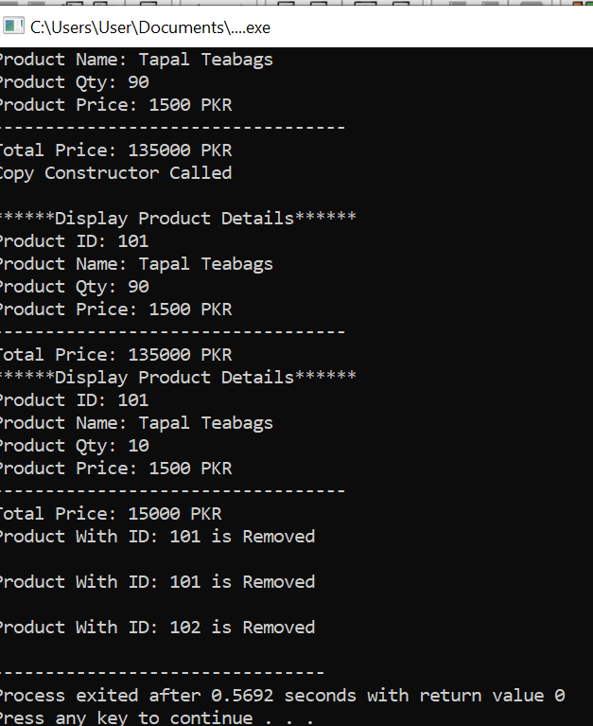

Program#2:
Hospital patient management system

#include <iostream>
#include <string>
using namespace std;

class Patient {
private:
int patientID;
string name;
int age;
string diagnosis;

public:
// Default Constructor
Patient() {
patientID = 0;
name = "Unknown";
age = 0;
diagnosis = "Unknown";
}

// Parameterized Constructor
Patient(int id, string n, int a, string d) {
patientID = id;
name = n;
age = a;
diagnosis = d;
}

// Copy Constructor
Patient(const Patient &p) {
patientID = p.patientID;
name = p.name;
age = p.age;
diagnosis = p.diagnosis;
}

// Destructor
~Patient() {
cout << "Patient with ID " << patientID << " is discharged." << endl;
}

// Function to update diagnosis
void updateDiagnosis(string newDiagnosis) {
diagnosis = newDiagnosis;
}

// Function to display details
void displayPatientDetails() {
cout << "\nPatient ID: " << patientID << endl;
cout << "Name: " << name << endl;
cout << "Age: " << age << endl;
cout << "Diagnosis: " << diagnosis << endl;
}
};

int main() {
// Default constructor
Patient p1;

// Parameterized constructor
Patient p2(101, "Ali Khan", 25, "Flu");

// Copy constructor
Patient p3 = p2;

// Update diagnosis
p2.updateDiagnosis("Severe Flu");

// Display details
cout << "Patient 1 Details:";
p1.displayPatientDetails();

cout << "\nPatient 2 Details:";
p2.displayPatientDetails();

cout << "\nPatient 3 Details (Copied from Patient 2):";
p3.displayPatientDetails();

// Destructor will automatically run when program ends
return 0;
}

Output:
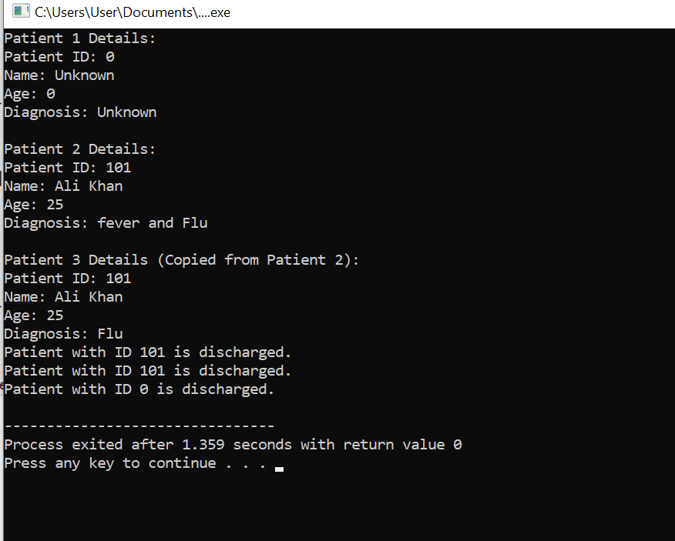

Program#3:

#include <iostream>
using namespace std;

class Car {
private:
int carID;
string model;
double rentPerDay;
bool isAvailable;

public:
// Default Constructor
Car() {
carID = 0;
model = "Unknown";
rentPerDay = 0.0;
isAvailable = true;
}

// Parameterized Constructor
Car(int id, string m, double rent, bool status) {
carID = id;
model = m;
rentPerDay = rent;
isAvailable = status;
}

// Copy Constructor
Car(const Car &c) {
carID = c.carID;
model = c.model;
rentPerDay = c.rentPerDay;
isAvailable = c.isAvailable;
}

// Destructor
~Car() {
cout << "Car with ID " << carID << " removed from system." << endl;
}

// Rent Car
void rentCar() {
if (isAvailable) {
isAvailable = false;
cout << "Car rented successfully!" << endl;
} else {
cout << "Car is already rented." << endl;
}
}

// Return Car
void returnCar() {
if (!isAvailable) {
isAvailable = true;
cout << "Car returned successfully!" << endl;
} else {
cout << "Car is already available." << endl;
}
}

// Display Details
void displayCarDetails() {
cout << "\nCar ID: " << carID << endl;
cout << "Model: " << model << endl;
cout << "Rent per Day: " << rentPerDay << endl;
cout << "Availability: " << (isAvailable ? "Available" : "Rented") << endl;
}
};

int main() {
// Default object
Car c1;

// Parameterized object
Car c2(101, "Toyota Corolla", 5000, true);

// Copy object
Car c3 = c2;

// Operations
c2.rentCar(); // Rent car
c2.displayCarDetails();

c2.returnCar(); // Return car
c2.displayCarDetails();

// Display all cars
cout << "\nCar 1 Details:";
c1.displayCarDetails();

cout << "\nCar 3 Details (Copied):";
c3.displayCarDetails();

return 0;
}
Output:

